Accessing Google Classroom

Classroom.google.com
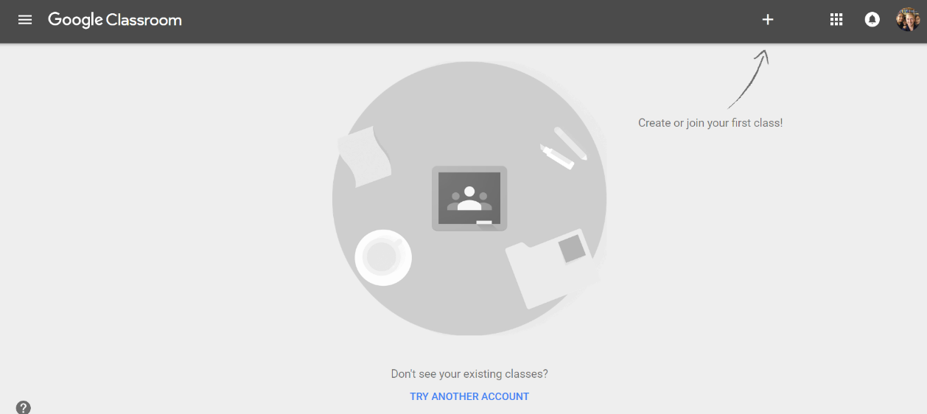

Click the icon to change the user.

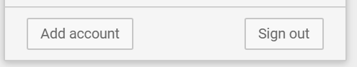Click Add Account

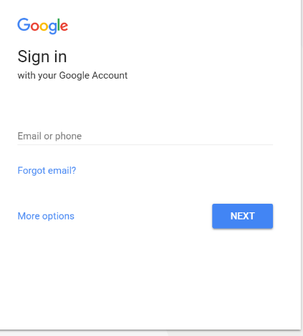

Student Email address

____________.________________@stu.austinisd.org

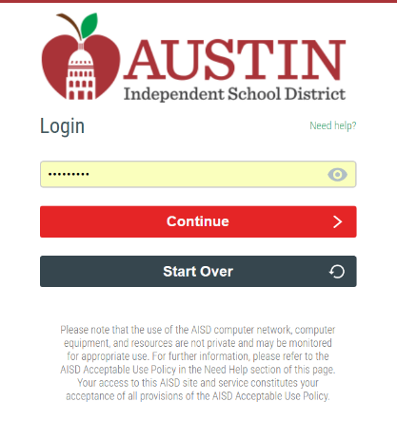
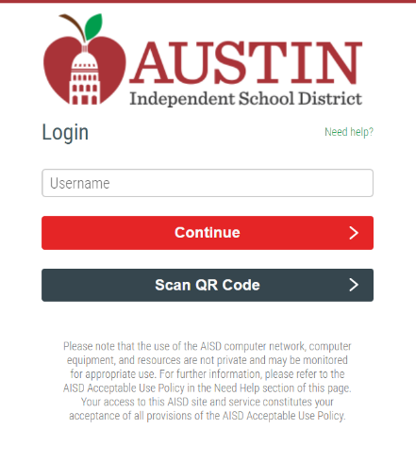

Student S# Password

S_________________ _ _ _ _ _ _ _ s

Capital first letter of last name
Birthday (mmddyy)

